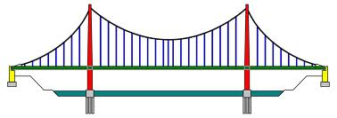
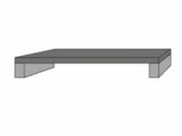
- The engineer of this suspension bridge fears that it will soon collapse due to the force of torsion. What can be added to this bridge to stop this from happening? Draw directly onto the image and explain your answer.

- What needs to be added to this arch bridge in order to overcome the force of compression? Draw directly onto the image and explain your answer.
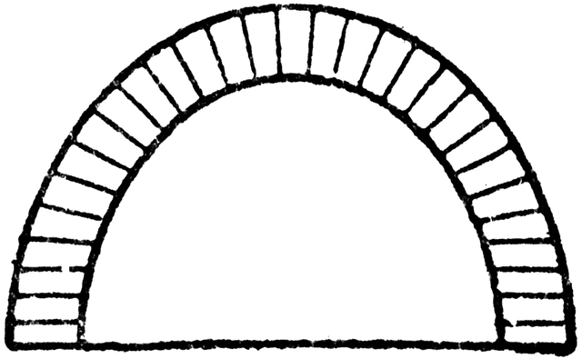

- Illustrate and explain the forces acting on the beam bridge. What could be added in order to help dissipate the load? Draw directly onto the image and explain your answer.

